SEMANTIC HTML WEB PAGES AND TAILWINDCSS SETUP


Arranged by:
Made Premadharma Yogananda (2415101056)

Computer Science Study Program
Department of Informatics Engineering
Faculty of Engineering and Vocational Studies
Universitas Pendidikan Ganesha
2026

- Semantic HTML Web Pages and CSS Styling
Create directory with the following structure
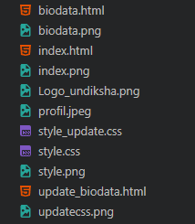
Here is the first website : biodata.html and style.css
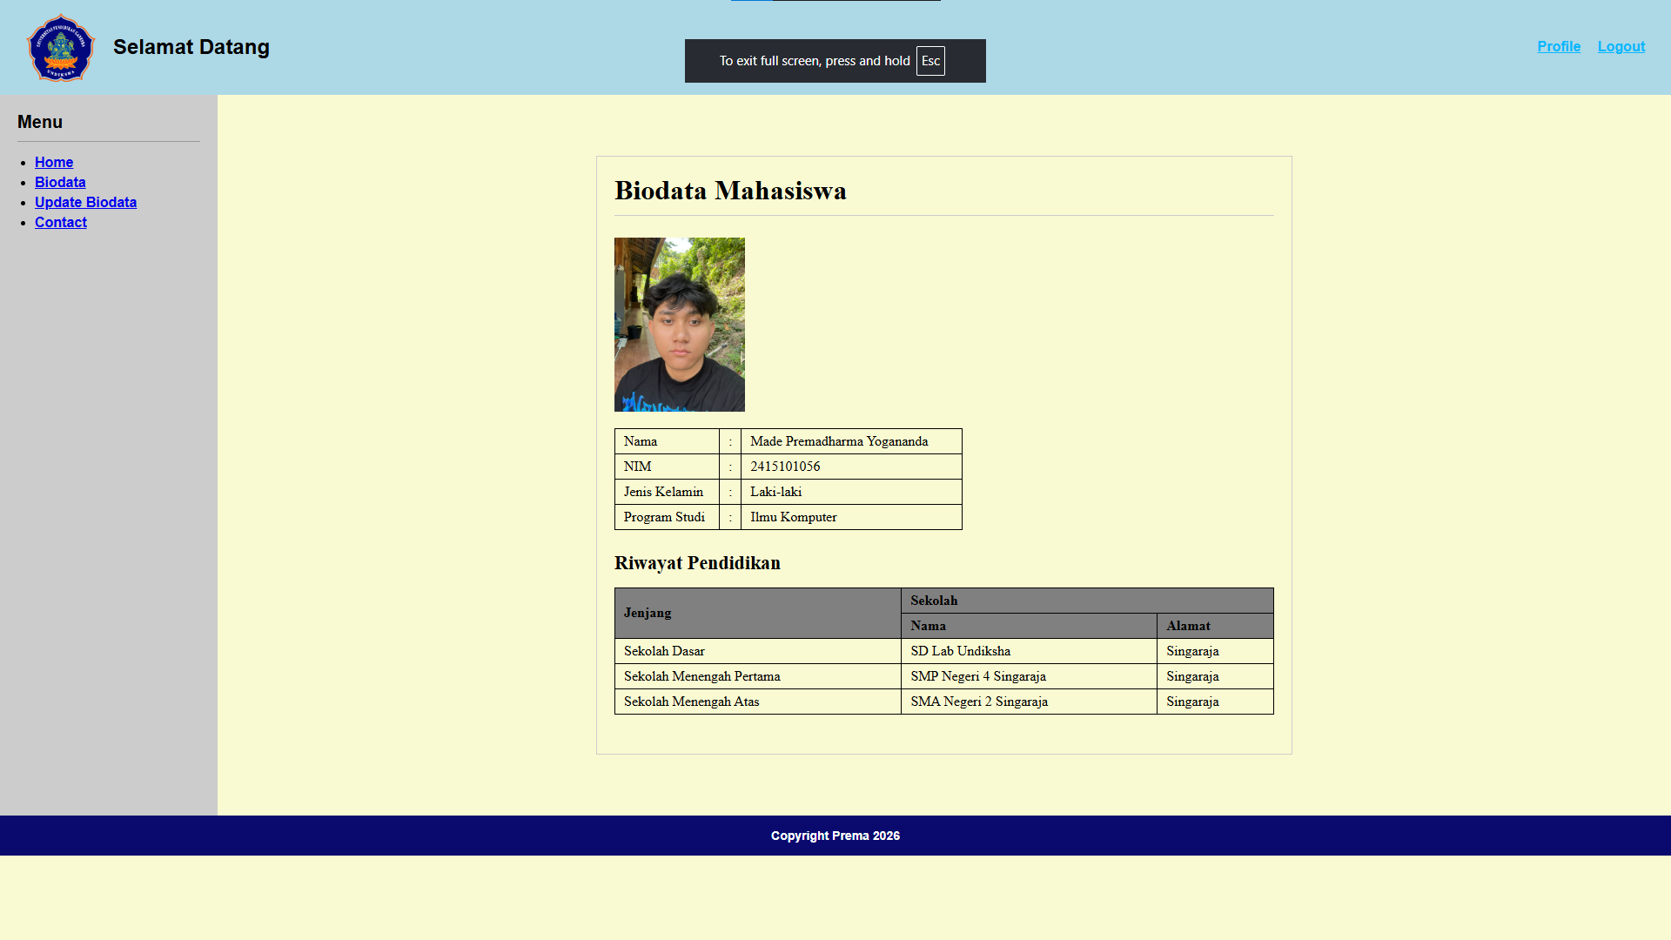

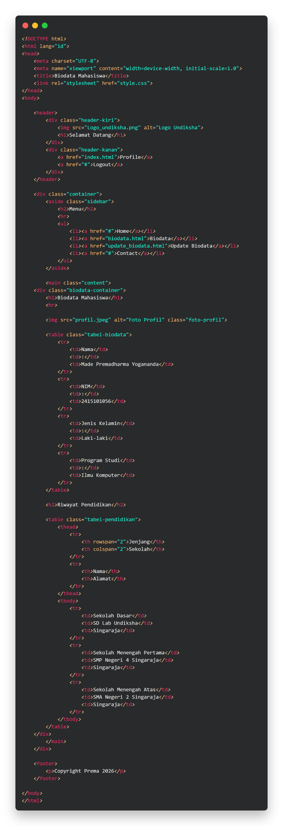
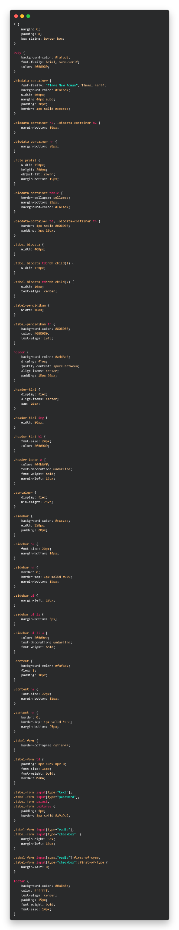
And this is the second website: update_biodata.html and the style.css
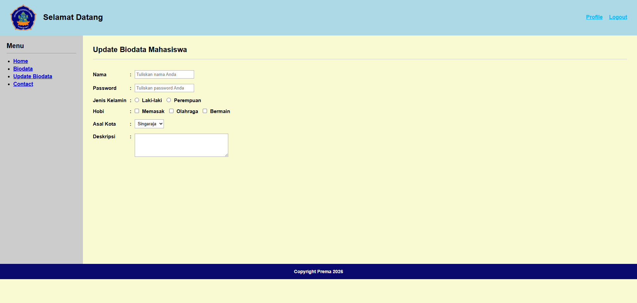
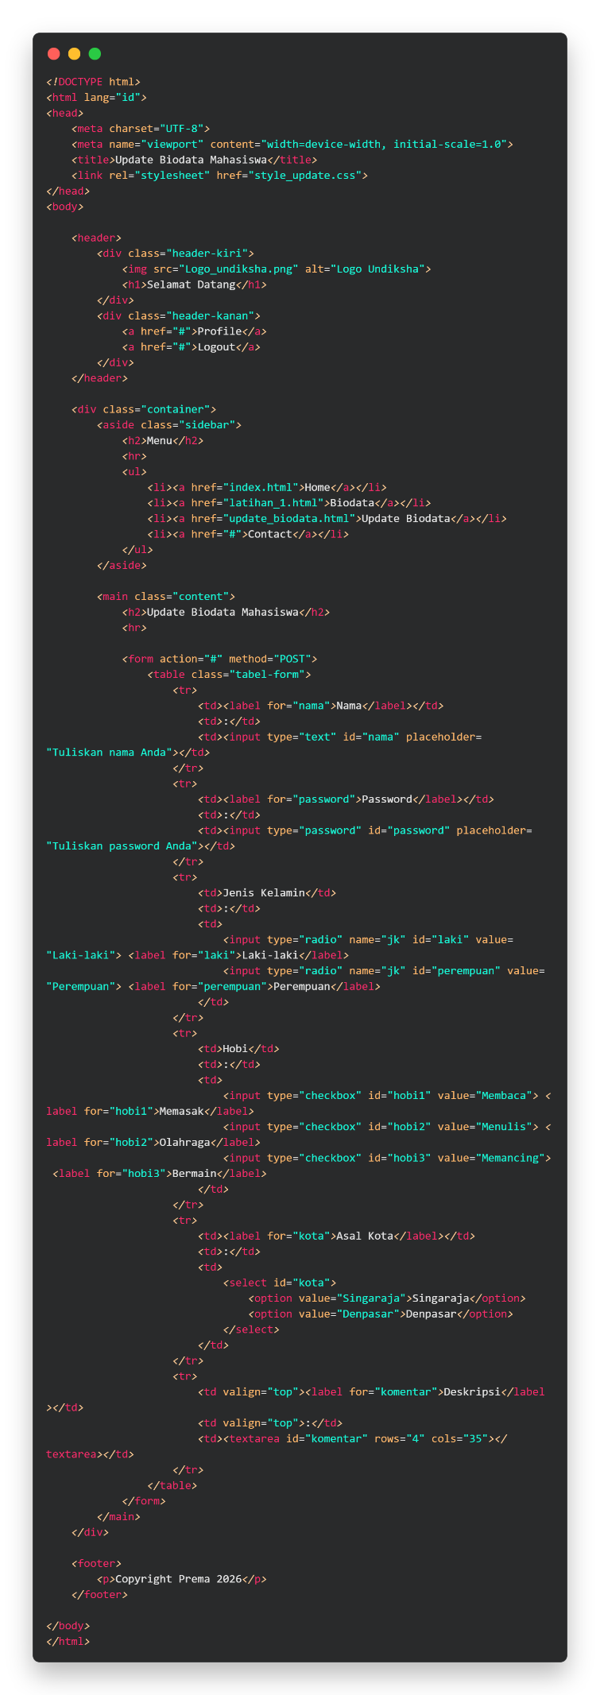
- Composer Installation
Windows Installer: https://getcomposer.org/download/
Version: Latest v2.10.3
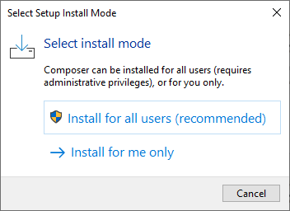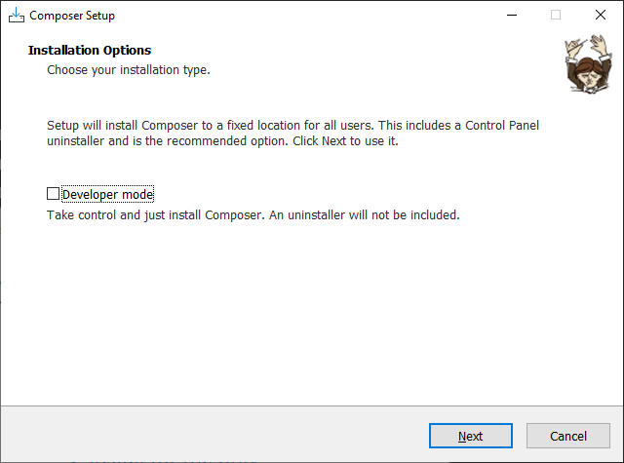
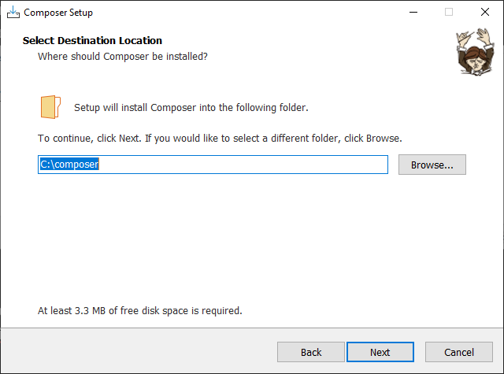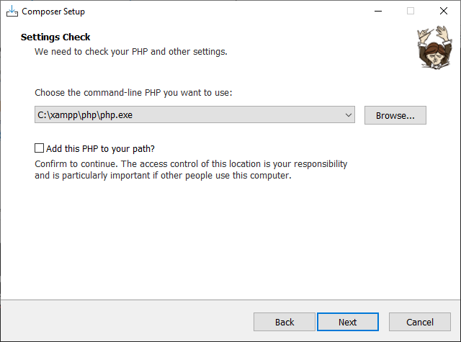
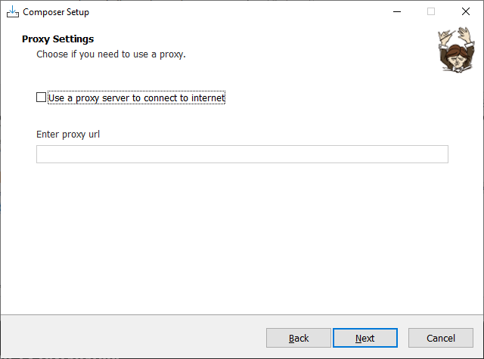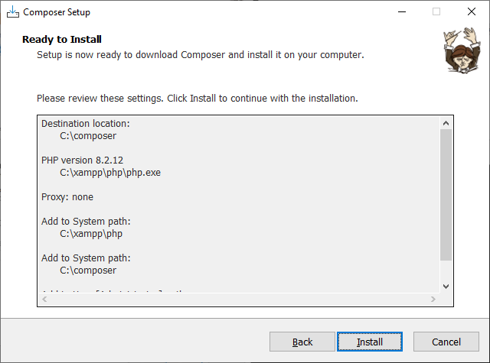
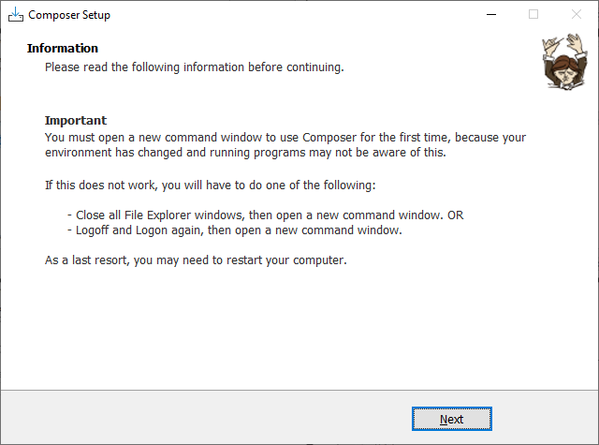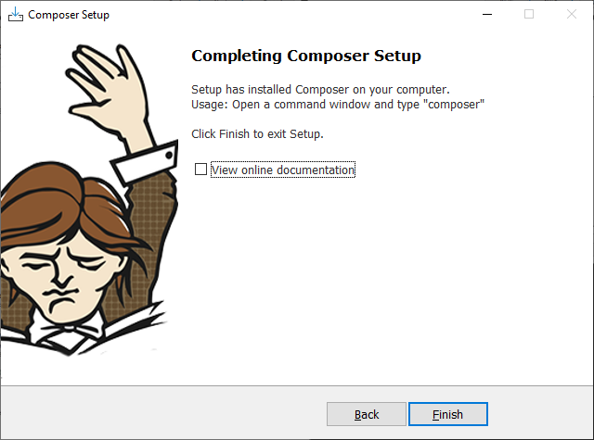

- NodeJS Installation
Windows Installer: https://nodejs.org/dist/v26.8.2/node-v26.8.2-x64.msi
Version: v26.8.2
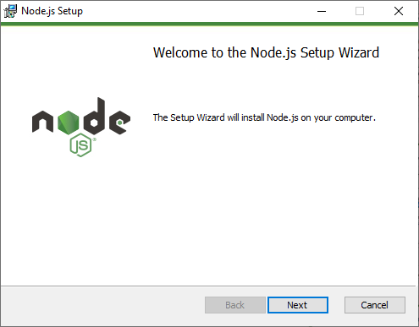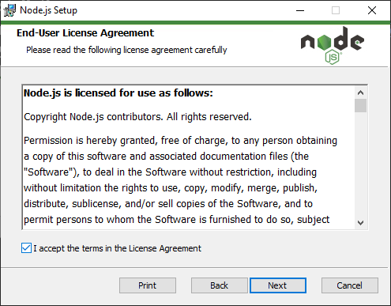
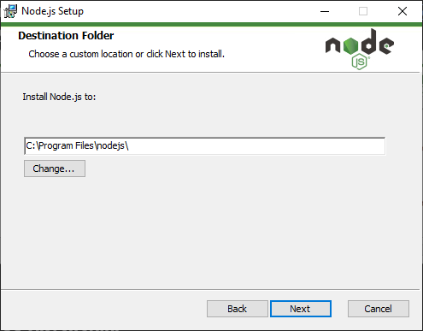
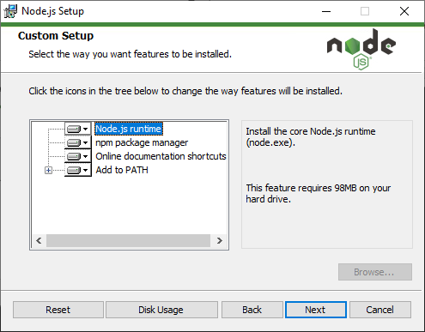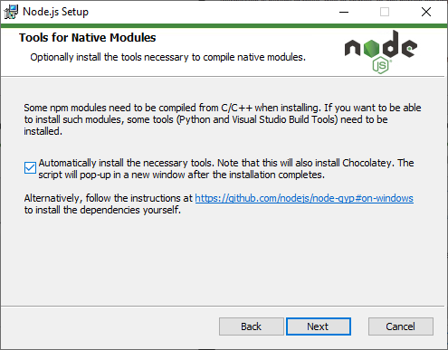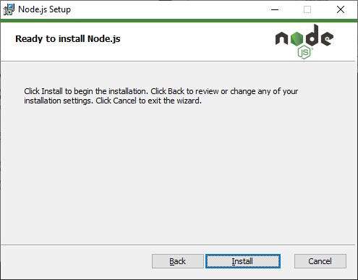
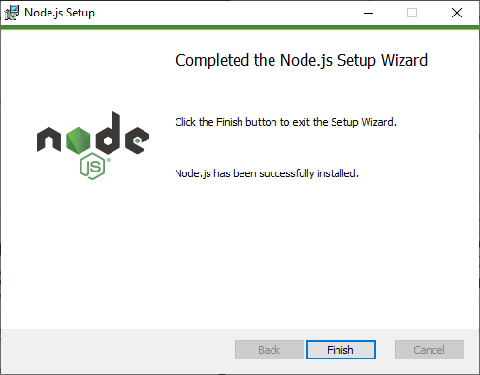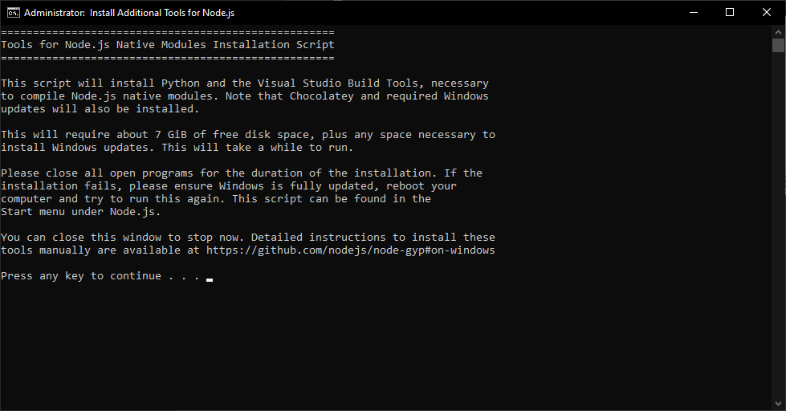

- TailwindCSS Installation
CLI Installer: https://tailwindcss.com/docs/installation/tailwind-cli
Installation Process:
- Npm init
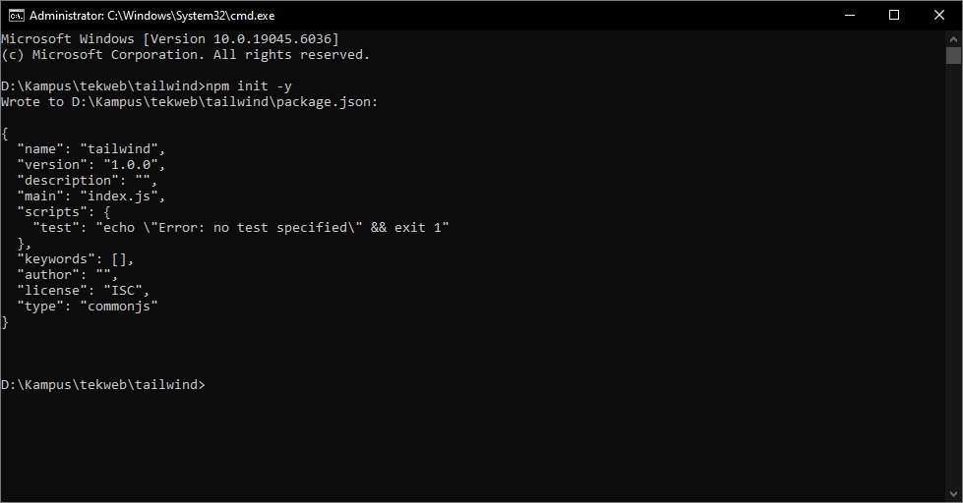
- Tailwind installation
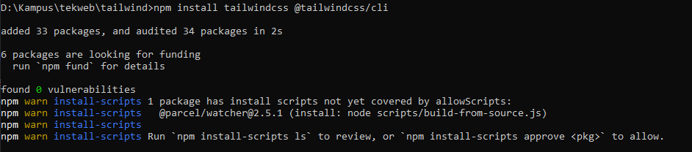
- Create src/input.css and src/index.html file
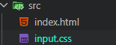
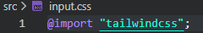

- executing the @tailwindcss/cli
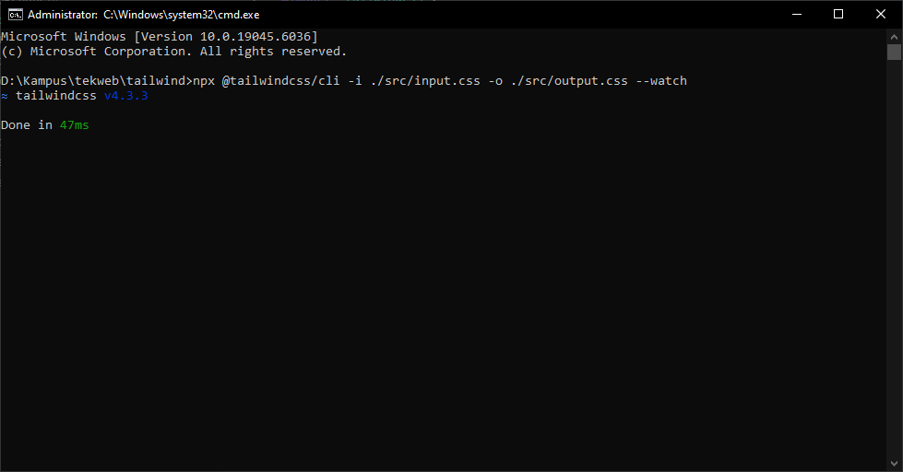
- create the index.html
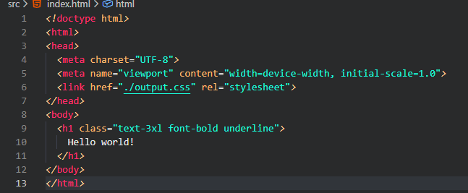
- run the website using live server plugin


